1. Register Page [10 mark]
+Create a Register page as following: [4]
+Save As: Index.html
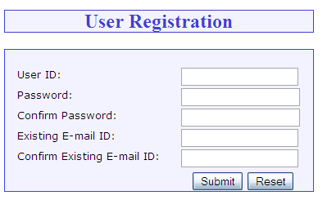
+Requirements: [6]
- Create mysite.css to contain all css styles for the page.
- All textboxes are required (do not allow blank input).
- Use Regular Expression to validate fields as following:
  - UserID must have at least 5 characters
  - UserID must start with a letter (a-zA-Z), others could be letters or numbers.
  - Password must have at least 8 characters. Password must include at least a letter and a number.
  - Confirmpassword and password must be matched.
  - Email must be a valid email. E.g.: marketing@gmail.com (pattern="^[a-zA-Z0-9_.+-]+@[a-zA-Z0-9-]+\.[a-zA-Z0-9-.]+$")
  - Confirm Email must match with Email field
- When user clicks Reset, rest all the fields to blank
- When user clicks Submit, if all fields are valid, redirect user to home.html
- When user clicks Submit, if any field is not valid, show a proper message to inform user which field is not valid. Then focus to the field.

2. Home Page [10 mark]
- Create a document named home-page.html as below design: [4]
  - Main content (to the right) is an section, which contains main content of web pages as below screen shots.
  - Left menu has 3 menus: Home (home-page.html), Reservation (reservation.html), Contact Us (contact-us.html)
  - These menus will use images
  - When user hover mouse over each menu, the menu must change to alternative image (or change to blue color as below screenshots)
  - When user choose a menu, change the page to respective page.
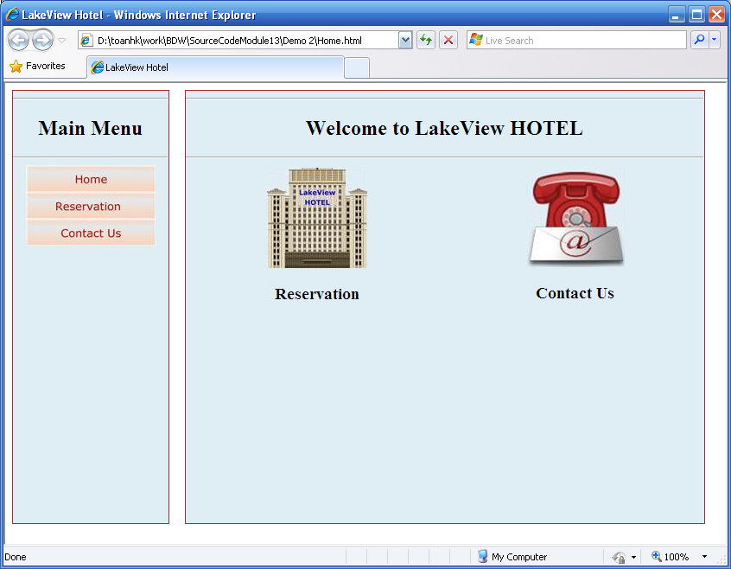
- When user clicks on “Reservation” (either on menu or image), change the main content as following design: [4]
  - Form Validation
Field | Validation
Name | Required
City | Data: Select… , Hà Nội, Huế, Hồ Chí Minh, Đà Nẵng, Đà Lạt, Cần Thơ, Vũng Tàu, Quảng Ninh, Hải Phòng, Hải Dương  Validate: Must choose a city (not allow to choose the default “Select…”)
Arrival Date / Departure Date | Required  Format must be “MM/dd/yyyy”
Number Of Rooms | Required  Must be integer
Number of Person | Required  Must be integer  Must be equal or more than number of rooms
  - Functions:
      - When user clicks “Clear Form”, clear all fields on form (to blank)
      - When user clicks on “Back”, go back to previous page where we came to current page.
      - When user clicks on “Submit”, perform validation. If all data valid, show an alert that “Reservation success! Thank you!”
      - If data validation fails, show proper message detail which field is not valid.

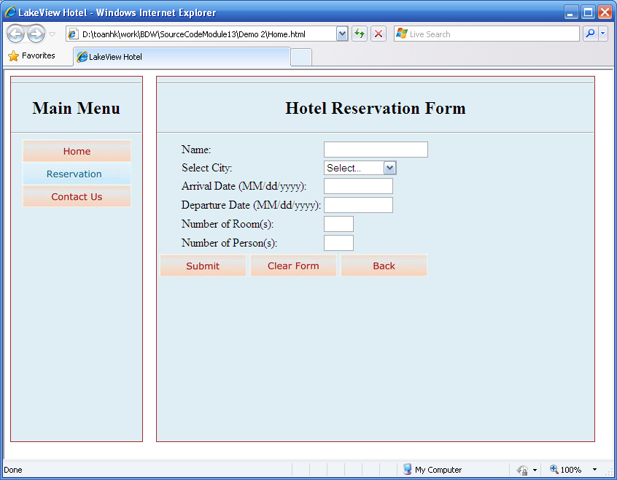
- When user clicks on Contact Us, show as below: [2]
  - When user clicks “Back”, go back to previous page which the user came from.
  - The email address must be linked to a proper email address.
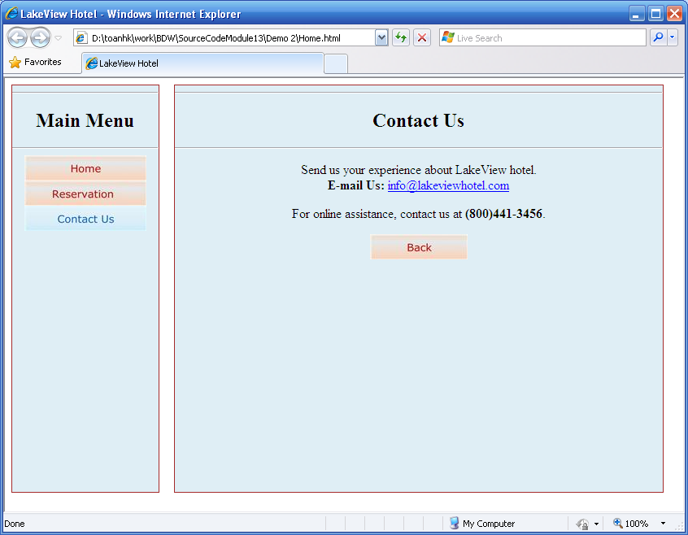

--- THE END ---

